**Getting Traffic on your Online Property using Adwords**

[**https://www.fragantiz.in/**](https://www.fragantiz.in/)

Google AdWords is Google's advertising system in which advertisers bid on certain keywords in order for their clickable ads to appear in Google's search results. This is the most simply way to get traffic to website in short time. The AdWords program includes local, national, and international distribution. AdWords offers services such as pay-per-click (PPC) advertising and cost-per-acquisition (CPA) advertising.  If the keywords you've chosen match what people search for, your paid ad appears next to or above organic **Google** search results.

For <https://www.fragrantiz.in/> - we running Google adwords campaign twice in a month. Best benefits I feel, reaching more customers, advertising locally or globally, and only paying for results. We can attract customers faster than organic seo. But its is paid advertising method, but we have full control over our investment, also conversion will be higher than organic SEO, with such a minimal cost our page will get best place in SERP.

**(Use of Google adwords to attain traffic)**

**Setup a google adwrods account for fragrantiz.in**

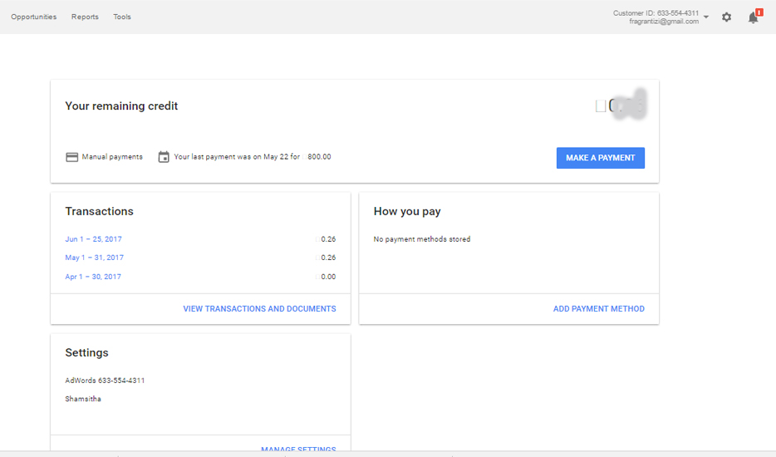

**Ad Groups**

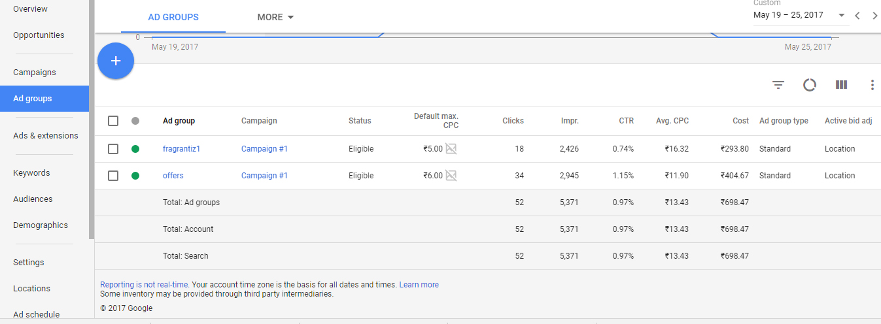

**Ads**

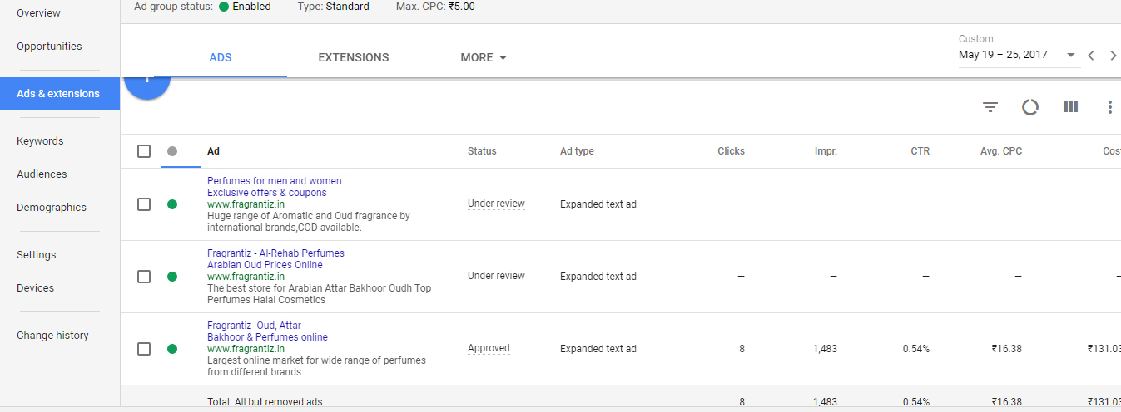

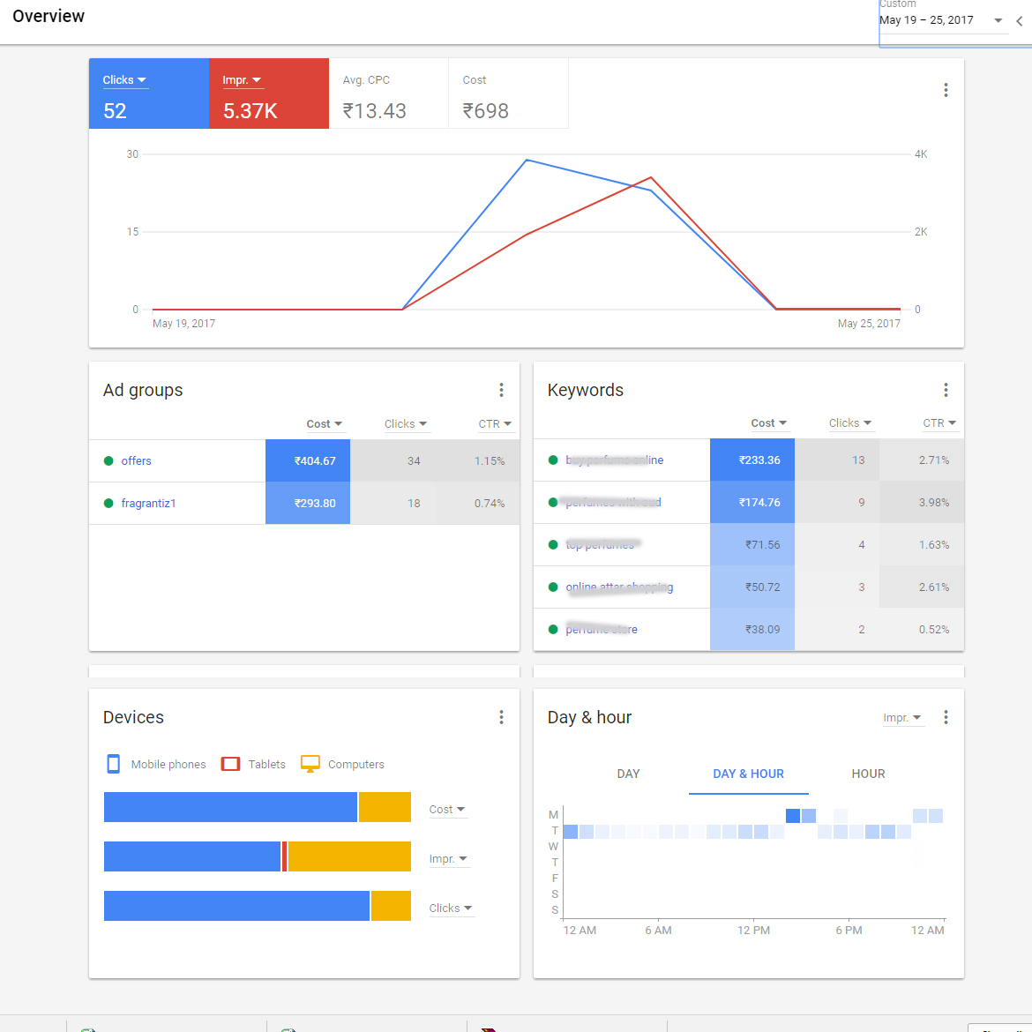

**Keyword list**

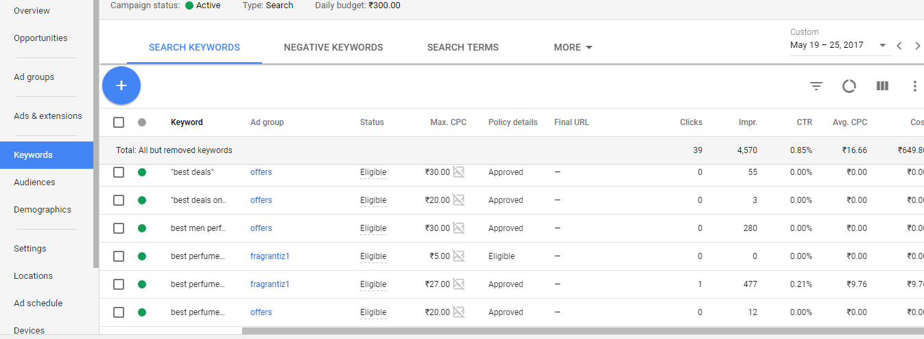

**Create ad Copies (Text Ads)**

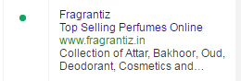

Ad Copy is comprised of:

* **Headline** - Headline is what shows at the top of ad. It’s in blue. 25 characters (including spaces) to write this prominent first impression.
* **Display URL** – My Display URL is what searchers see as the page enticing them to visit.
* **Description Line 1 and Description Line 2** – We can have 35 characters per line for the ‘body’ of your Ad Copy.

**Research and set bids, CPCs and Daily budget**

In order to run an ad in Google we need to specify budget and bidding options. **maximum cost-per-click bid (max. CPC bid)** is the most willing to pay for a click on our ad. Daily **budget** establishes a charging limit per day. For Eg: I ve set my ads with RS.230/- so my campaign will run till this amount finish. Daily budgets are editable, but google will take 24 hrs to take this effect or live.

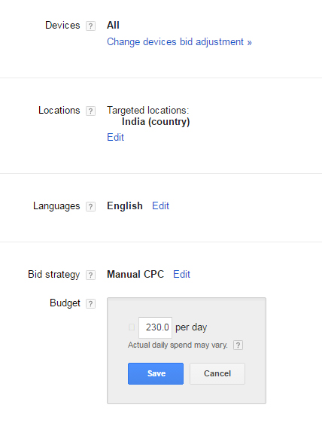

**Bid adjustment as required as per location, device and schedule**

In Bid adjustment help us to show the ads based on preferred location or device we chosen in the settings. Different types of adjustments available, so it is easy to reach the ads to target audience.

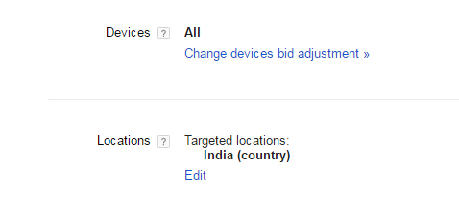 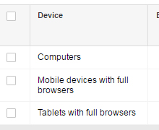

**Create Image Ads and select the placements on Display Network**

Image ads will capture more attraction from user. Image ads must follow the policies of google adwords, like sizes of image.

**The Image ad steps and placement screenshots explains below with screenshots:-**

**Screenshot explain how to create image ads**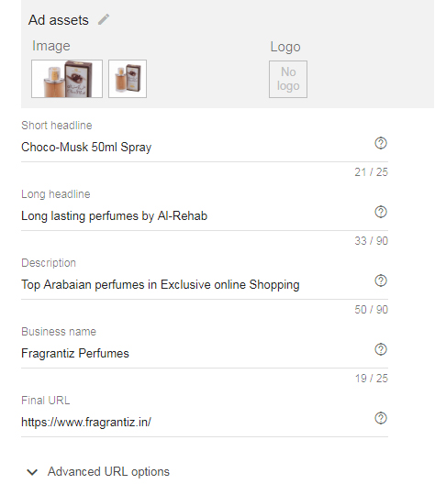

**Different placements on display network**

